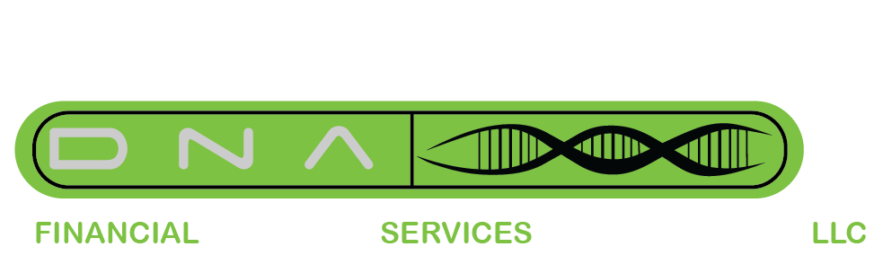

For Immediate Release
Contact: Dwayne Mitchell
August 28, 2017

DNA Financial Services LLC Announces Open Registration for the 1st Financial Empowerment Workshop Series
Courses begin at 6:30 PM and run until 8:00PM on Wednesday, September 6th, 2017 and each following Wednesday at Dearborn High School. 19501 W. Outer Drive, Dearborn, MI. Registration is now open.

August 28, 2017 — Today, DNA Financial Services LLC announced that open registration is underway for the Financial Empowerment Workshop Series, which begins at 6:30 PM on Wednesday, September 6^{th,} 2017 at Dearborn High School. Prospective metropolitan Detroit attendees are able to choose from ten weeks of financial literacy courses aimed at making personal money management and wealth building easier to understand while bridging the gap between stabilizing personal finance and establishing wealth building goals.

Our company is committed to helping change the narrative in this region when it comes to financial education. These courses were set up as a bridge from initial financial literacy to wealth building strategies. Subjects include financial behaviors, personal spending plans, taxes, paying off debt, insurance, investment fundamentals and much more. “This series of financial literacy courses will be different from anything people in our community may have previously taken,” said Angela Mitchell, Chief Wealth Strategist at DNA Financial Services LLC.
Prospective participants must register at dearbornCEonline.org or call 313-827-1959. Each session is $35, and the series runs through November 15th, 2017.

Positive Customer Impact
Many customers have already benefited from working with DNA Financial Services through one on one coaching consultations and seminars set up to equip and empower anyone seeking financial education.

Founded in 2015, DNA Financial Services LLC has pledged to Educate, Empower and Equip the financial DNA of its’ clients now and for generations to come. The company offers a number of financial services designed to bridge the gap in wealth building education while aiding and advocating for the financial literacy of people from all walks of life.
###

For more information, press only:
Senior Wealth Strategist: Angela Mitchell
Phone Number: 248-805-2218
angelamitchell@debtnotallowed.com

For more information on The Financial Empowerment Workshop Series:
www.debtnotallowed.com

Tags: Financial Education, Financial Literacy, Empowerment, Personal Finance, Wealth Building, workshops

